Work Placement Report

**Internship at Tata Consultancy Services**

**Leveraging Quantum Computing in Risk Analytics**

**August 21, 2021**

**Sherry AGGARWAL**

**CID - 01948430**

**Introduction**

Once considered a scientific impossibility, quantum computing is now entering the commercial sphere with its potential impact being realized across different sectors, especially the Financial Services Sector. Quantum computing marries the properties of quantum physics with advanced computer science, creating a powerful combination of speed, accuracy, and processing capability. There is a limit to how much a classical computer can achieve and it scales exponentially while quantum computers scale polynomially.

Financial institutions are already exploring the quantum computing realm to quadratically speed up complex calculations while also considerably improving accuracy. They are vying for a competitive advantage by embracing the survival of the fittest concept and employing the most cutting-edge technology available, with Quantum being the next big thing.

This project focuses on understanding quantum technology in the risk analytics space and designing an architecture blueprint to adopt the technology. Various research case studies using quantum computing are analysed and an adoption roadmap is charted out for the organization to start experimenting and leveraging the technology. Furthermore, various quantum challenges are identified and different mitigation strategies are discussed.

**Project objective**

Tata Consultancy Services (TCS) is the second-largest IT services company in the world. It helps customers achieve their business objectives by providing innovative, best-in-class consulting, IT solutions, and services, with over $23 billion annual revenues, and operates in 149 locations in 46 countries. The firm offers a consulting-led, integrated portfolio of IT and IT-enabled services, including application development, business intelligence, enterprise solutions, engineering and industrial services, asset leveraged solutions, and business process services. It operates through the following segments: Banking Financial Services & Insurance (BFSI); Retail & Consumer Business; Communication, Media, & Technology; and others. Bespoke teams are built around client domain and technology requirements. The organization structure is domain-led and empowered to help provide customers a single window to industry-specific solutions.

With quantum computing becoming a possible future, this project is a part of TCS’s thought leadership and creative solutions. Senior leadership recognizes that this is a game-changing opportunity, so they want to be quantum-ready by preparing a go-to-market strategy to add disruptive and innovative value to customer’s solutions.

This 8-week project was fundamentally a research and development study and had four broad objectives –

1. Understanding quantum technology in general and assessing the current industry trends
2. Building an industry use case universe for the risk and compliance domain
3. Designing a blueprint for the adoption process
4. Listing industry challenges and proposing solutions to mitigate those challenges based on learnings

The project scope did not cover any implementation plans or outcomes as it was primarily a learning exercise for TCS.

The final proposition deck was presented to the senior management and a feedback assessment was carried out to expand on the project, which included building a cross-industry overview and an overall industry outlook from an adoption perspective. An exhaustive comparison of quantum service providers was made to understand the solutions and products commercially available in the banking and financial domain and for TCS to leverage the technology.

This report details the objectives and the findings along with the skills and knowledge applied to achieve them.

**Objective1**

**Understanding quantum technology in general and assessing the current industry trends**

Before beginning the research for quantum in the financial area, it was necessary to understand what makes quantum computing so distinct from classical computers, so broad knowledge was developed around the technology.

Quantum technology harnesses the principles of quantum physics to process data and performs computation. The two most important concepts are 'Superposition' and 'Entanglement'. In classical computers, data is represented as either 1 or 0 via a bit. In quantum computers, data can simultaneously exist in a state of 1 and 0 via a qubit, known as quantum superposition. Due to entanglement, even though two or more qubits may be physically separated, their behavior is correlated. This correlation holds whether the separation is measured in meters or miles. So, while one qubit can be in a superposition of two basis states, ten qubits can be in a superposition of 1024 basis states via entanglement [1]. This phenomenon leads to an exponential growth of the possible states that increase quantum computers' predictive powers, allowing them to solve complex equations at once.

Quantum computing is not a new phenomenon rather existed as a theoretical concept for some decades, but 2014 saw a significant industry interest when tech giant IBM announced $3 Billion in quantum research [2]. Since then, quantum appears to have made significant progress in terms of both hardware and software. Many start-ups and partnerships between industries and technology providers have sprung up to translate the theoretical concepts into practical applications accelerating the overall development [3].

Though the broader application of quantum technology is still uncertain, financial services firms have started identifying the areas where its impact can be realized. According to McKinsey & Company, ‘the finance sector is the most likely industry to significantly reap the quantum benefits in the near-term’ [4]. The potential challenges in finance include the uncertainty and unconstrained optimization problems at which quantum computing excel. The probabilistic nature of quantum technology makes hacking tricky, which is game-changing for cryptography-related challenges. Furthermore, financial firms are losing $10- $40 billion every year due to fraud and poor data management practices, and the data modeling capabilities of quantum can provide improved accuracy and better predictions [5]. According to IBM's report, there is a revenue potential of $5 billion alone in Portfolio management, credit scoring, and risk analysis [5].

The biggest hurdle in realizing the full potential of quantum computers is scaling the technology. The qubits are very sensitive to the outside world and the slightest disturbance induces errors. A fully error-corrected quantum computer requires thousands of qubits and controlling those many qubits is a major engineering challenge. So, in the noisy intermediate-scale quantum (NISQ) era, devices with errors are used to develop quantum algorithms and hybrid approaches to achieve superior results and prepare for a quantum leap. One such technique is quantum annealing that finds the lowest energy state for a complex system. For portfolio optimization problems, the lowest energy state will minimize the risk and provide the highest returns. Hybrid approaches are adopted where both classical and quantum computers are used together to achieve better results.

As proofs-of-concept and proprietary ecosystems are established, it's clear that getting involved immediately is critical. To use quantum computing to tackle real-world issues, a number of collaborations have been created. Quantum technology is becoming a national priority, with the United States and Canada having the most well-funded startup ecosystems in the world. [6].

**Learning Outcome**

This exercise helped in understanding the hype around the technology and why financial firms need to have a game plan. Regular brainstorming sessions were held with the team to pave the way for further research and focus primarily on quantum in the risk and compliance domain.

**Objective2**

**Building an industry use case universe for the risk and compliance domain**

The next step for TCS to begin its quantum journey was to evaluate current success stories and learn from scientific research in the financial services industry, which has seen several recent quantum algorithm discoveries.

The general industry tendency is to collaborate with research institutions, universities, and quantum entrepreneurs to build a proof of ideas using cloud-based services. Though the hardware is the most challenging barrier, institutions are building applications today to take advantage of early adoption benefits before the hardware is available.

Quantum potential has been realized primarily in three areas [6] in the risk and compliance domain –

1. Optimization – Many financial models are optimization problems, including portfolio management and rebalancing, capital allocation, and option pricing. With greater transparency requirements by regulators and compliance issues, the complexity of the system increases. In this complicated landscape, quantum computers can consider real-time constraints with full complexity and provide an optimal solution just in a fraction of a second compared to classical computers.
2. Machine Learning (ML) – With the wider adoption of machine learning in the financial industry, especially in customer-focused analytics and fraud detection algorithms, adding more variables and parameters increases the complexity of models and takes more time to train and implement. With quantum computers, ML techniques would work at a quadratic pace and speed up the processes.
3. Simulation and Pricing – Financial institutions are required to run risk profiling in real-time to improve capital allocation, hedge positions, and derivative pricing under strict regulations. The most preferred algorithm – Monte Carlo simulation – is limited by the scaling of estimation error. Quantum computer's data processing capabilities can speed up the process and simulate multiple scenarios simultaneously, providing better outcomes.

Quantum risk analyses have already been tested on quantum computers for sample problems such as risk analysis on European-style options and portfolio optimization. So different research papers were studied to learn (see Table1) where quantum technology stands today in terms of use cases discovered by some leading companies in the risk domain. Most of these studies prove that quantum computers perform better than classical ones for small-scale problems and then theorize how the algorithms can be expanded on a large scale once hardware improves.

An exhaustive comparison of quantum service providers was conducted to understand how and where these case studies can bring business benefit to TCS requires implementation. The providers were evaluated on five key characteristics – end-to-end solution/full stack ecosystems, commercial maturity, hardware partners, financial solutions, and consulting support. The majority of small start-ups are competing in software applications accessible via cloud services. However, full-stack solutions are provided by the leading tech giants. IBM has built the "Q Network" comprising hardware, software, and quantum toolkits to access quantum as a cloud-based service. Similarly, Amazon's AWS Bracket and Microsoft's Azure platform both launched their quantum cloud services.

In terms of hardware, different companies are exploiting the quantum nature of the particles by developing processors with different techniques. IBM and Google are focussing on superconducting processors. Companies like Xanadu are exploring light's ability to carry information across networks to develop photonic layers [13]. Another approach adopted by Honeywell is using trapped-ion technology to hold quantum information and encode using lasers [14].

**Learning outcome**

The use case repository and tech providers analyses will help TCS understand the existing solutions and test some algorithms at their end to build on the existing capability and include them in their innovative offerings. Since most of the use cases were around risk modeling, optimization module knowledge was leveraged to deep dive into the academic research papers and prepare a detailed summary.

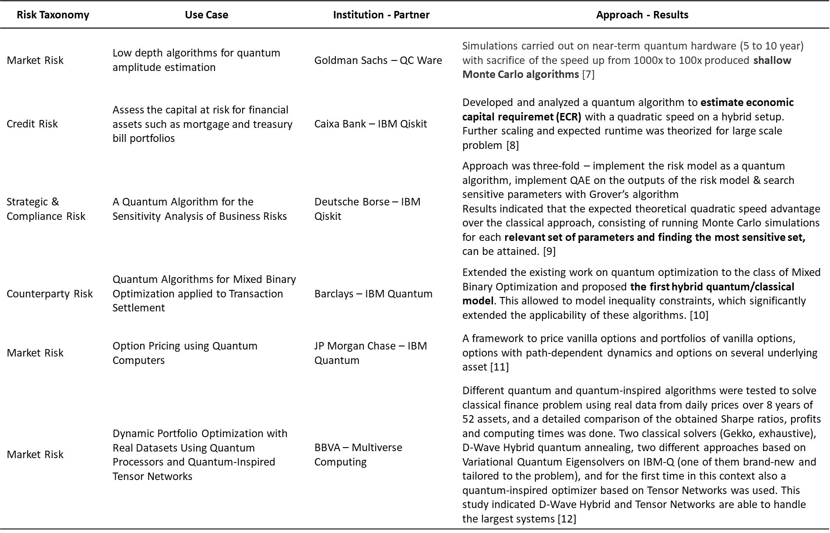Table1: Use Case repository

**Objective3**

**Designing a blueprint for the adoption process**

A crucial aspect of this report was learning from the industry and developing a quantum computing adoption process to leverage the technology. So, the process was divided into six building blocks which TCS can follow to adopt the technology and be prepared for potential customer collaborations –

1. Identify use cases – Exploring quantum use cases pertaining to the risk domain and identify business areas where these use cases can be implemented to maximize the impact.
2. Business opportunity – Based on the use case universe, prioritize the concept aligned with the company's strategic positioning and build a business case to seek approval from senior leadership.
3. Preparing ecosystem – Quantum skills are limited, so start preparing an ecosystem by training specialists with quantum computing and risk analytics skills. Partnerships are crucial for exploring quantum applications, so collaborate with quantum providers to turn the academic theory into business practice.
4. Experiment – Run pilot projects on open software and start monitoring the results as quantum programming is fundamentally different from other programming languages. Speed up the learning curve for early adopter advantage by accessing the read-to-use libraries.
5. Chart your course – Learn from the experiments, run gap analysis in terms of skillset, infrastructure, and data requirement and join quantum communities to develop a quantum roadmap. Rethink strategies and find ways to tackle new challenges.
6. Future roadmap – Quantum computing space is still evolving, so it is important to be up to date with the new developments and progression in the risk domain. Revise the strategy based on breakthroughs and seek new toolkits to stay ahead of the curve.

The above process is further broken down into straightforward steps (ref Figure1), which can help TCS provide an innovative offering to its customer base.

**Learning Outcome**

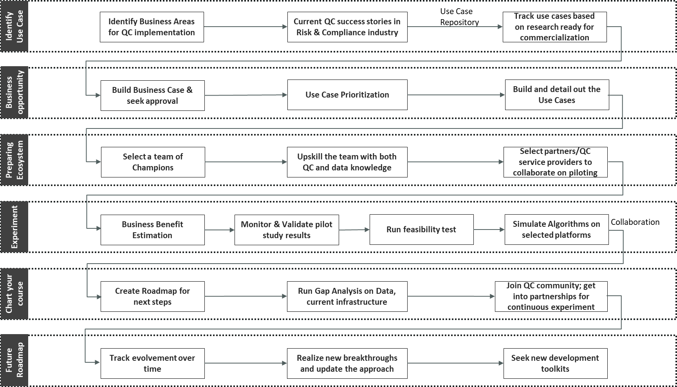Figure1: Industry Adoption – Business Process Flow

**Objective4**

**Listing industry challenges and proposing solutions to mitigate those challenges based on learnings**

The quantum technology is likely to break current computing standards, so TCS needs to seize the opportunity, but the adoption process is non-trivial. There are various challenges in building quantum capability and the company needs to anticipate them and prepare solutions accordingly. So, the next part of the research focussed on identifying these hurdles in the risk and compliance domain and propose various solutions to mitigate them based on learnings and industry standards.

Table2 lists some of the critical issues discussed in various forums along with the proposed strategies. Though hardware and costing challenges are common across all sectors, there is a great concern for the risk and compliance industry. A recent workshop by FCA in July 2021 [16] brought up some unprecedented challenges raised by different participating stakeholders, including the Bank of England, UK universities, and the National Quantum Computing Centre (NQCC), among which policy and the regulatory issue was one of the major concerns. With the uncertainty of using quantum as a service to process data, there is an emerging contention about how policymakers should react to this to remain technologically neutral in their response. Also, the industry is highly competitive, which can influence releasing new advancements without proper safety considerations. Currently, technology is concentrated in the hands of large technology firms - Google, Microsoft, IBM, and Amazon Web Services. They are already leading the contractual arrangements and they possess enormous leverage when negotiating licenses and services agreements. Hence, introducing transparency and risk management under industry regulation becomes an urgent need. So sooner the challenges are addressed, more focus could be on maximizing the QC potential.

**Learning outcome**

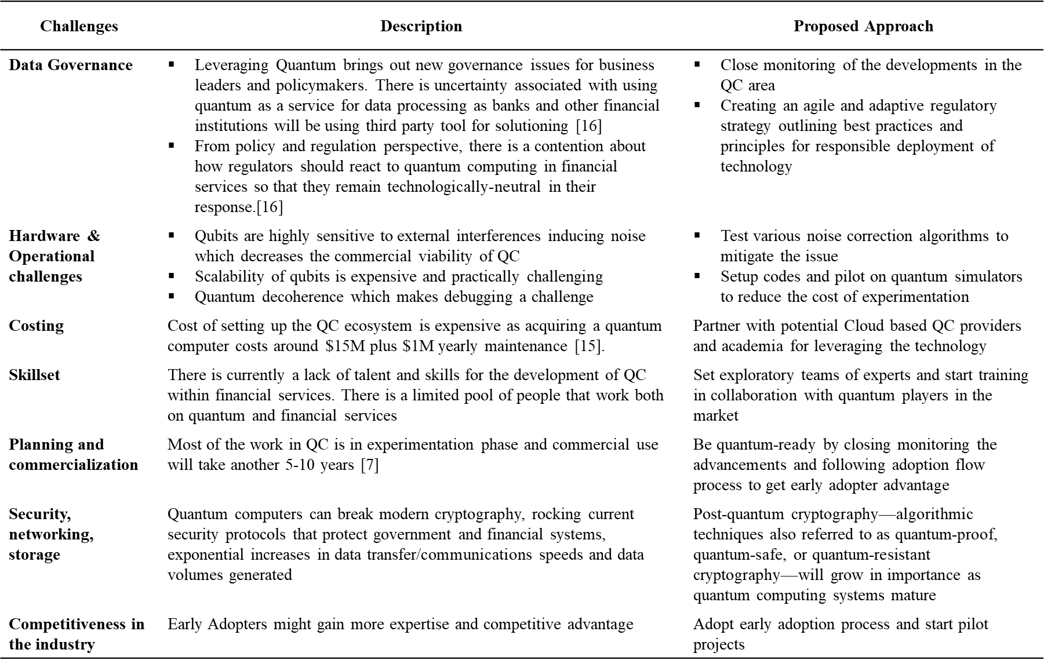Table2: Industry Challenges

**Feedback Assessment**

When shared with the senior leaders, the above study gave them a consolidated view of current advancements in the quantum field in the risk domain. However, the quantum potential is also explored across other sectors, so a cross-industry outlook was prepared based on the feedback. An industry outlook was provided from an adoption perspective.

Quantum is proving to be a significant advancement in various sectors, including telecommunications, pharmaceuticals, cybersecurity, and aerospace. Nevertheless, every industry has specific use cases suited to quantum computing, so it becomes tricky to capture different stages of advancement across industries. So, to get a more expansive view of quantum landscape McKinsey & Company [17] surveyed to create a maturity curve (ref Figure2) for different sectors, across five categories: bystanders, beginners, learners, professionals, and legends. This view helped us create an industry-wide overview and search for industries more advanced in this field than financial firms.

Technology firms are further down the maturity curve, having achieved quantum supremacy, developed an industrial quantum computer, and established cloud-based quantum computing services [17]. Successful deployment of quadratic unconstrained binary optimization (QUBO) model in network planning by TIM (Telecom Italia) gave an advantage to the telecommunications industry, making them professionals along the maturity curve [18]. Financial Services and Pharma are at the learner level of quantum maturity. For instance, it has

already begun to hire quantum scientists to support possible use cases for quantum simulation in optimization and drug design.

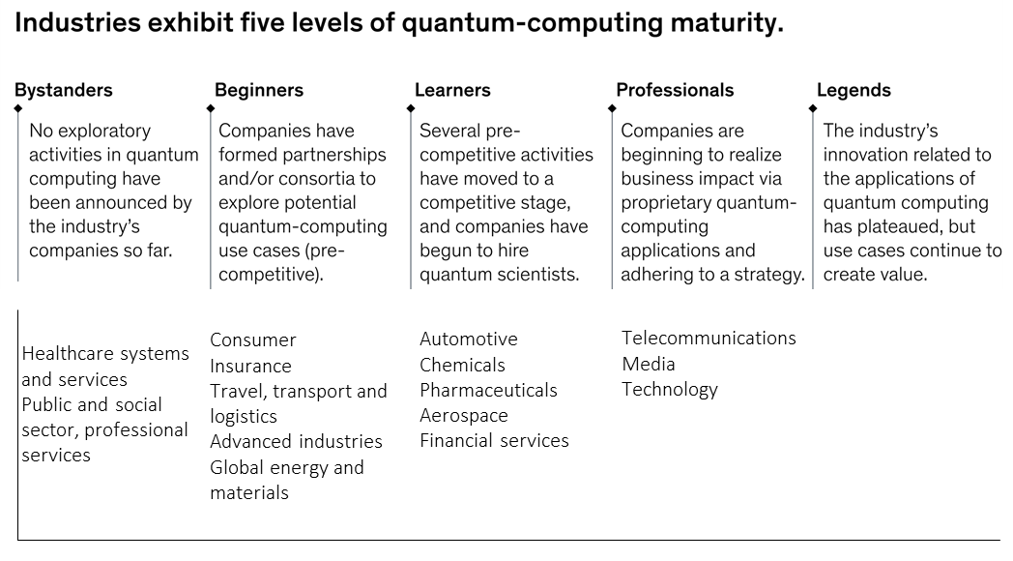Figure2 : Maturity Curve for different industries [17]

Finally, an overall industry outlook suggested the following key points –

* The services segment accounts for the majority of the quantum computing market.
* Cloud-based deployment is witnessing high demand in the quantum computing world.
* Optimization accounted for a significant share of the overall quantum business.
* A primary focus is on building quantum algorithms before hardware is ready.
* Scalability and introducing noise-free qubits are the primary hardware challenges.
* Current use case testing is on a combination of annealers, quantum simulators, and low-bit quantum computers.
* Quantum Innovation is driven by collaborations and partnerships between leading companies and software-hardware providers.

**Conclusion**

As a next step, TCS will use this research as a fundamental guide for reference and start developing quantum capability by reaching out to the service providers and following the proposed adoption process. This study is a foundation for continuous research in this emerging field and will help align with customers' strategic and tactical priorities. Though fully fault-tolerant universal quantum computers are years away, TCS must engage now as proofs-of-concept are being built, standard toolkits are released and ecosystems are set up.

**Note –** This study is conducted solely based on the information available online, and none of the TCS's proprietary information was used.

**References:**

[1]Ibm.com. 2021. [online] Available at: <https://www.ibm.com/downloads/cas/MBZYGRKY> [Accessed 5 August 2021].

[2] IBM Newsroom. 2021. *IBM Announces $3 Billion Research Initiative To Tackle Chip Grand Challenges For Cloud And Big Data Systems*. [online] Available at: <https://newsroom.ibm.com/2014-07-09-IBM-Announces-3-Billion-Research-Initiative-To-Tackle-Chip-Grand-Challenges-For-Cloud-And-Big-Data-Systems> [Accessed 12 August 2021].

[3] G, J., 2021. *Quantum computing’s commercial outlook*. [online] Quantum Zeitgeist. Available at: <https://quantumzeitgeist.com/quantum-computings-commercial-outlook/> [Accessed 12 August 2021].

[4] McKinsey & Company. 2020. [online] Available at : <https://www.mckinsey.com/business-functions/mckinsey-digital/our-insights/a-game-plan-for-quantum-computing> [Accessed 12 August 2021].

[5] IBM. 2021. *Quantum computing use cases for financial services*. [online] Available at: <https://www.ibm.com/thought-leadership/institute-business-value/report/exploring-quantum-financial> [Accessed 12 August 2021].

[6] Investment Monitor. 2021. *Quantum computing: believe the hype*. [online] Available at: <https://investmentmonitor.ai/analysis/quantum-computing-believe-the-hype> [Accessed 20 August 2021].

[7] Giurgica-Tiron, T., Kerenidis, I., Labib, F., Prakash, A. and Zeng, W., 2021. *Low depth algorithms for quantum amplitude estimation*. [online] arXiv.org. Available at: <https://arxiv.org/abs/2012.03348> [Accessed 12 August 2021].

[8] Egger, D., Gutiérrez, R., Mestre, J. and Woerner, S., 2021. *Credit Risk Analysis using Quantum Computers*. [online] arXiv.org. Available at: <https://arxiv.org/abs/1907.03044> [Accessed 20 August 2021].

[9] Braun, M., Decker, T., Hegemann, N., Kerstan, S. and Schäfer, C., 2021. *A Quantum Algorithm for the Sensitivity Analysis of Business Risks*. [online] arXiv.org. Available at: <https://arxiv.org/abs/2103.05475> [Accessed 12 August 2021].

[10] Braine, L., Egger, D., Glick, J. and Woerner, S., 2021. *Quantum Algorithms for Mixed Binary Optimization applied to Transaction Settlement*. [online] arXiv.org. Available at: <https://arxiv.org/abs/1910.05788> [Accessed 12 August 2021].

[11] Stamatopoulos, N., Egger, D., Sun, Y., Zoufal, C., Iten, R., Shen, N. and Woerner, S., 2021. *Option Pricing using Quantum Computers*. [online] arXiv.org. Available at: < https://arxiv.org/abs/1905.02666> [Accessed 12 August 2021].

[12] Mugel, S., Kuchkovsky, C., Sanchez, E., Fernandez-Lorenzo, S., Luis-Hita, J., Lizaso, E. and Orus, R., 2021. *Dynamic Portfolio Optimization with Real Datasets Using Quantum Processors and Quantum-Inspired Tensor Networks*. [online] arXiv.org. Available at: <https://arxiv.org/abs/2007.00017> [Accessed 12 August 2021].

[13] Xanadu. 2021. *Photonic Quantum Hardware*. [online] Available at: <https://www.xanadu.ai/hardware> [Accessed 12 August 2021].

[14] Honeywell.com. 2021. *Honeywell Quantum Solutions And Cambridge Quantum Computing Will Combine To Form World's Largest, Most Advanced Quantum Business*. [online] Available at: <https://www.honeywell.com/us/en/press/2021/06/honeywell-quantum-solutions-and-cambridge-quantum-computing-will-combine-to-form-worlds-largest-most-advanced-quantum-business> [Accessed 12 August 2021].

[15] Investment Monitor. 2021. *Quantum computing: believe the hype*. [online] Available at: <https://investmentmonitor.ai/analysis/quantum-computing-believe-the-hype> [Accessed 12 August 2021]

[16] FCA Insight. 2021. *A Quantum Leap for Financial Services*. [online] Available at: <https://www.fca.org.uk/insight/quantum-leap-financial-services> [Accessed 12 August 2021].

[17] McKinsey & Company. 2021. [online]. Available at : <https://www.mckinsey.com/business-functions/mckinsey-digital/our-insights/tech-forward/the-current-state-of-quantum-computing-between-hype-and-revolution> [Accessed 12 August 2021].

[18] Capacitymedia.com. 2021. *TIM uses quantum computing live on its mobile networks*. [online] Available at: <https://www.capacitymedia.com/articles/3824971/tim-uses-quantum-computing-live-on-its-mobile-networks> [Accessed 20 August 2021].